**Report on Communication and Fault Analysis of JK_BD6A24S-8P JK BMS**

* **Revision Number:**  
  Rev. 1.0
* **Date of Creation or Update:**  
  20/12/2024
* **Prepared By:**  
  Maria Tabasum Shoaib(Firmware Engineer)
* **Reviewed By:**
* **Approved By:**

**Table of Contents**

1. **Introduction**
2. **Overview of the System**
3. **Steps Undertaken**
4. **Findings and Analysis**
5. **Recommendations and Conclusion**

**1. Introduction** The purpose of this report is to document the process of communicating with the JK_BD6A24S-8P JK Battery Management System (BMS) via its RS485 port, identify the observed inconsistencies, and present the findings that led to the conclusion that the BMS unit is faulty. The report details the steps undertaken, the methods of testing, and the final observations.

**2. Overview of the System**

* **BMS Model:** JK_BD6A24S-8P
* **Battery Specifications:** 72V, 30A
* **BMS Specifications:** 80A
* **Communication Protocol:** RS485
* **Test Setup:**
  + Battery connected to the BMS
  + Data commands sent via firmware over the RS485 port
  + Mobile application used for verification and cross-checking

**3. Steps Undertaken**

**3.1 Initial Setup and Communication:** The JK BMS was connected to the battery, and the RS485 communication interface was configured. Basic commands were sent to the BMS to retrieve data parameters such as cell voltages, state of charge (SOC), and temperature readings. The aim was to validate the communication link and ensure the BMS was providing consistent and accurate data.

**3.2 Observed Issues** During the initial communication:

* Data received from the BMS was inconsistent.
* Certain IDs returned partial or no data, disrupting the expected response pattern (shown in Fig. 1).

**3.3 Verification Using Mobile Application** To verify the anomalies observed via the RS485 communication:

* The JK_BMS was paired with its proprietary mobile application.
* Data parameters such as cell voltages and SOC were inspected.
* The application revealed that certain cell voltages (specifically cells 3, 11, and 19) were not showing any readings, confirming a potential fault in the BMS (shown in Fig. 2).

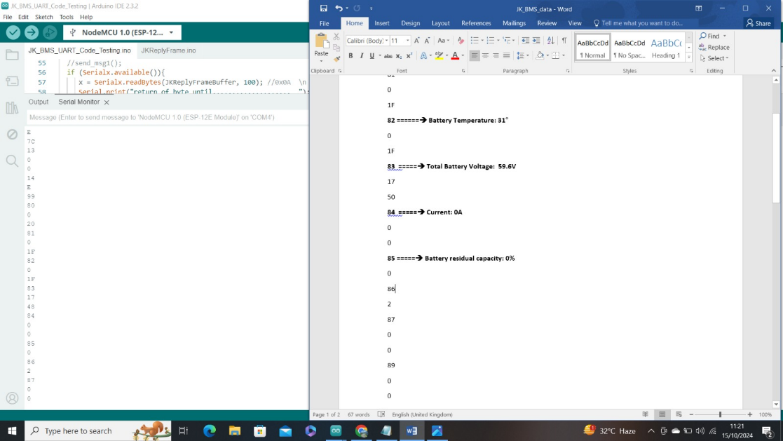

**Figure 1:** Inconsistent data received from JK_BD6A24S-8P

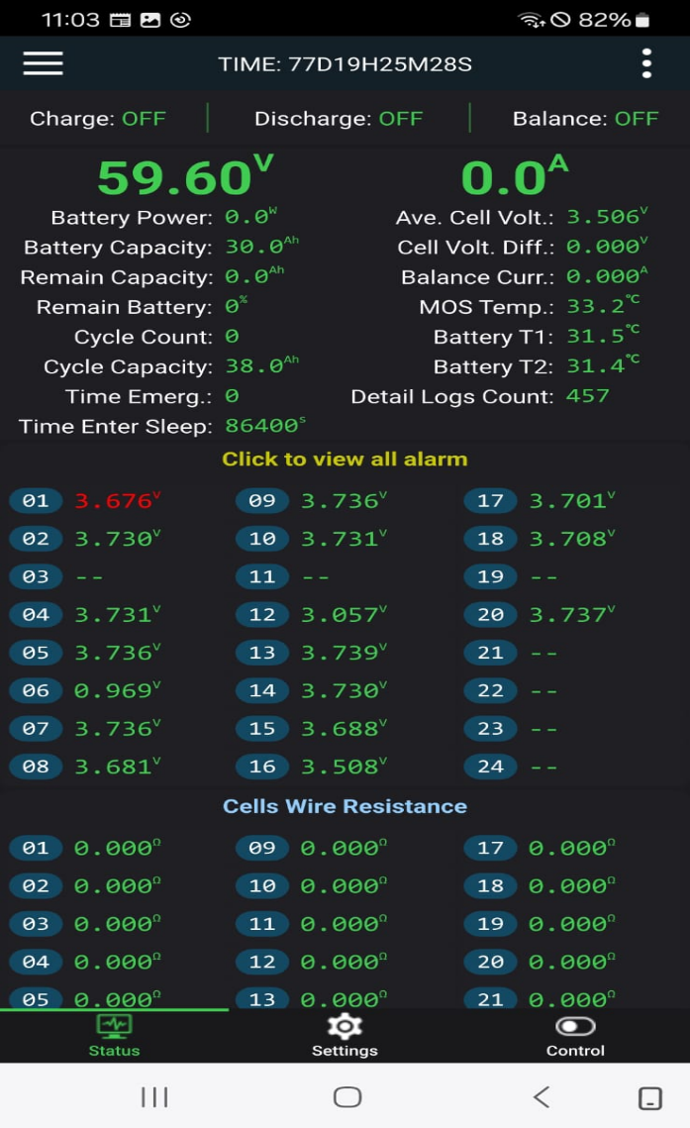

**Figure 2:** Missing cell voltages (3, 11 and 19)

**4. Findings and Analysis**

**4.1 Data Communication Issues**

* The RS485 interface was initially functional but displayed erratic behaviour due to the underlying fault in the BMS.
* IDs had to be sent in sequential order, and any deviation disrupted communication.

**4.2 Fault Confirmation**

* Cell voltages for cells 3, 11, and 19 consistently failed to display on the mobile application, indicating hardware-level issues with the BMS.
* These faults directly contributed to the inconsistencies observed during RS485 communication.

**4.3 Impact of the Fault**

* The faulty BMS can lead to inaccurate monitoring of cell voltages, which is critical for battery safety and performance.
* Erratic data could potentially harm connected devices relying on accurate BMS outputs.

**5. Recommendations and Conclusion**

**5.1 Recommendations**

* **Replacement of the Faulty BMS:** It is recommended to replace the JK_BD6A24S-8P unit with a functional BMS to ensure reliable monitoring and communication.
* **Thorough Testing of Replacement Unit:** The replacement unit should be rigorously tested for both RS485 communication and mobile application data consistency before deployment.
* **Consideration of Alternative Models:** Evaluate other BMS models with robust communication protocols and proven reliability.

**5.2 Conclusion** The JK_BD6A24S-8P BMS was found to be faulty due to missing cell voltage readings for cells 3, 11, and 19. This fault led to inconsistent data responses when communicating over the RS485 interface. Verification via the mobile application confirmed the hardware issues. Immediate action was taken to replace the faulty unit to maintain the integrity and safety of the battery management system.